*Supplement of*

## Improved global estimation of seasonal variations in C3 photosynthetic capacity based on eco-evolutionary optimality hypotheses and remote sensing

Yihong Liu a, Jing M. Chen a, b *, Mingzhu Xu b, Rong Wang b, Weiliang Fan c, Wenyu Li a, Lucas Kammer a, Collin Prentice d, Trevor F. Keenan e, f, Nicholas G. Smith g

*a Department of Geography and Planning, University of Toronto, Toronto, Canada*

*b School of Geographical Sciences, Fujian Normal University, Fuzhou, China*

c School of Environmental and Resources Science, Zhejiang A&F University, Hangzhou, 311300, China

*d Department of Life Sciences, Imperial College London, London, UK*

e Climate and Ecosystem Sciences Division, Lawrence Berkeley National Laboratory, Berkeley, CA, USA

f Department of Environmental Science, Policy and Management, UC Berkeley, Berkeley, CA, USA

g Department of Biological Sciences, Texas Tech University, Lubbock, TX, USA

***⁎*** *Corresponding author at: Department of Geography and Program in Planning, University of Toronto, Toronto, Canada, and School of Geographical Sciences, Fujian Normal University, Fuzhou, China.*

*E-mail address: jing.chen@utoronto.ca (JM. Chen)*

**Table S1** Leaf parameters used in the PROSPECT model for each PFT. *N* refers to structure parameter, *Car* refers to carotenoid content, *Cb* refers to brown pigment, *Cm* refers dry matter, and *Cw* refers equivalent water thickness. ENF = Evergreen needleleaf forest, EBF = Evergreen broadleaf forest, DBF = Deciduous broadleaf forest, MF = Mixed broadleaf forest, SHR = Shrubland, SAV = savanna; GRS = Grassland, CRO = Cropland

|  |  |  |  |  |  |  |
| --- | --- | --- | --- | --- | --- | --- |
| **PFT** | ***N*** | ***Car* (μg·cm-2)** | ***Cb*** | ***Cm* (g·cm-2)** | ***Cw* (g·cm-2)** | **Reference** |
| ENF | 2.8 | LCC/7 | 0 | 0.05 | 0.01 | De Santis et al. (2009) & Kötz et al. (2004) |
| EBF | 1.8 | LCC/7 | 0 | 0.005 | 0.01 | Arellano et al., 2017a, 2017b |
| DBF | 1.2 | LCC/7 | 0 | 0.005 | 0.01 | Féret et al. (2011) |
| MF | 1.2 | LCC/7 | 0 | 0.005 | 0.01 | Féret et al. (2011) |
| SHR | 1.8 | LCC/7 | 0 | 0.005 | 0.01 | Enrique et al. (2016) & Sow et al. (2013) |
| SAV | 1.2 | LCC/7 | 0 | 0.005 | 0.01 | Féret et al. (2011) |
| GRA | 1.2 | LCC/7 | 0 | 0.005 | 0.01 | Darvishzadeh et al. (2008) |
| CRO | 1.4 | LCC/7 | 0 | 0.015 | 0.01 | Jacquemoud et al. (2000) |

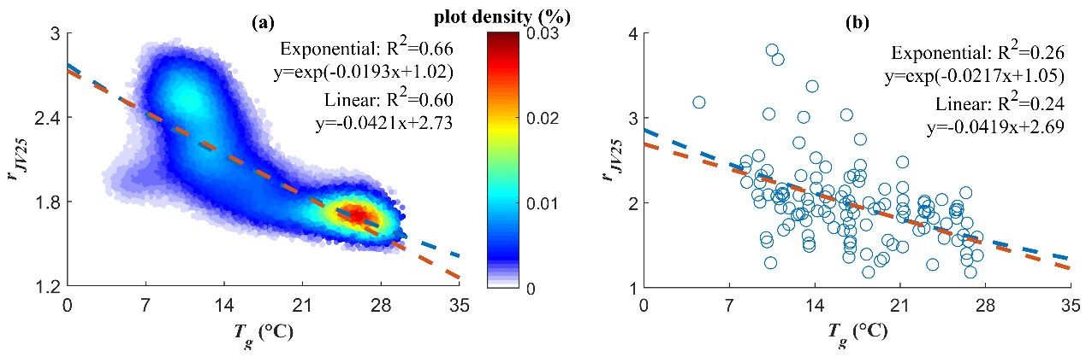

**Fig. S1.** Relationships between (**a**) RS-*rJV25* and *Tg* and between (**b**) *rJV25* from the global observation dataset and *Tg*. The blue dashed lines are the exponential empirical relationships, and the red dashed lines are the linear ones.

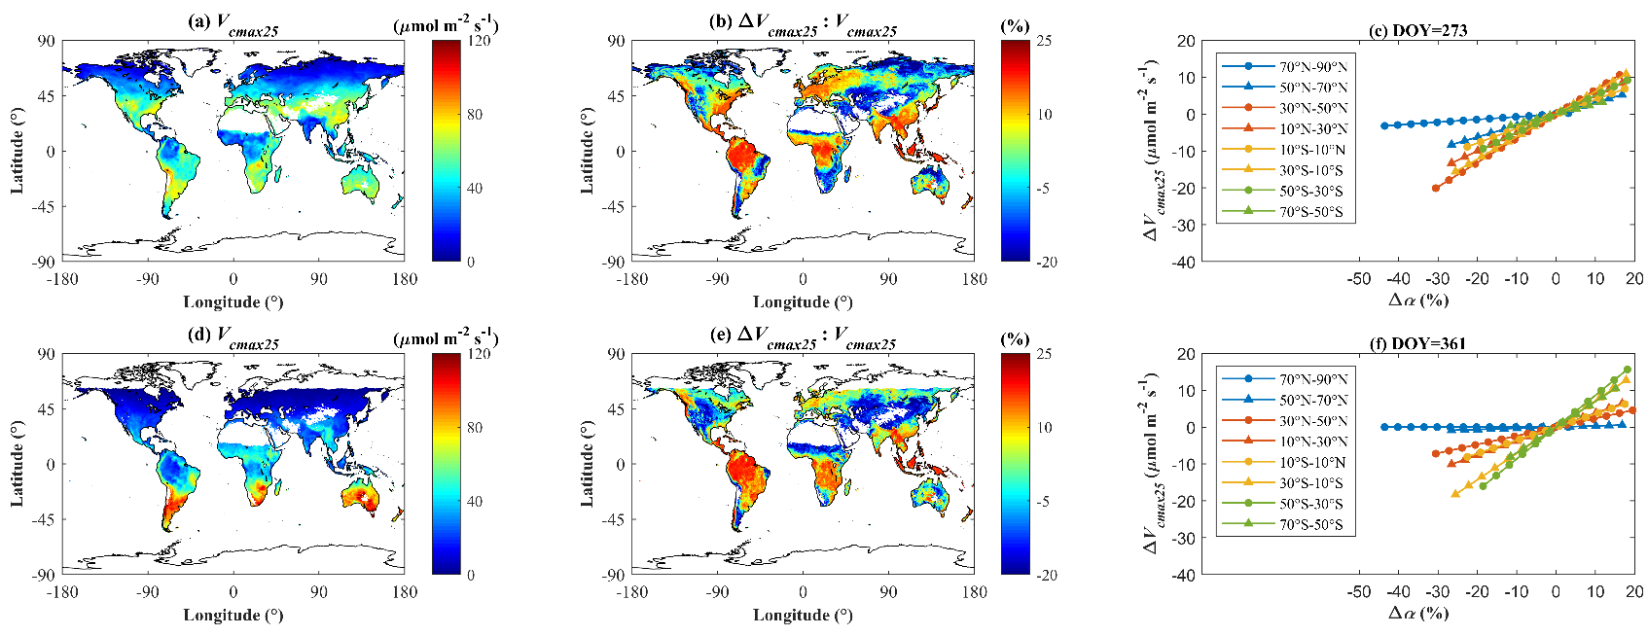

**Fig. S2. (a)** and **(d)** Global distributions of simulated *Vcmax25* of Scheme 4 at DOY 273 and 361, respectively; **(b)** and **(e)** Global distributions of Δ*Vcmax25* relative to Scheme 4 at DOY 273 and 361, respectively; **(c)** and **(f)** Sensitivity of Δ*Vcmax25* to variations in $α$ in different regions at DOY 273 and 361, respectively. The global mapsonly show areas with positive estimates, while the other areas are in blank.

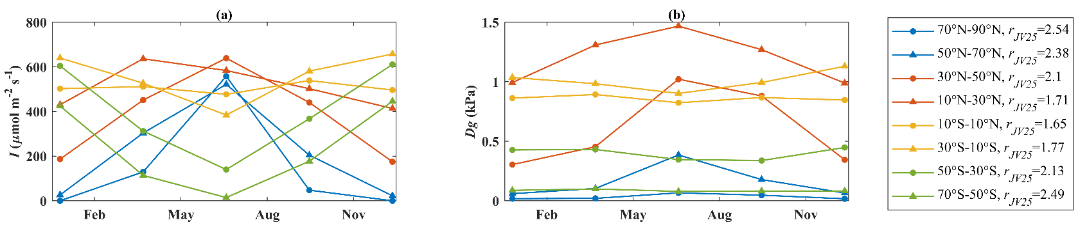

**Fig. S3.** Averaged **(a)** *I* and **(b)** *Dg*for different latitudinal regions used in the sensitivity test in Figs. 5 and S1.

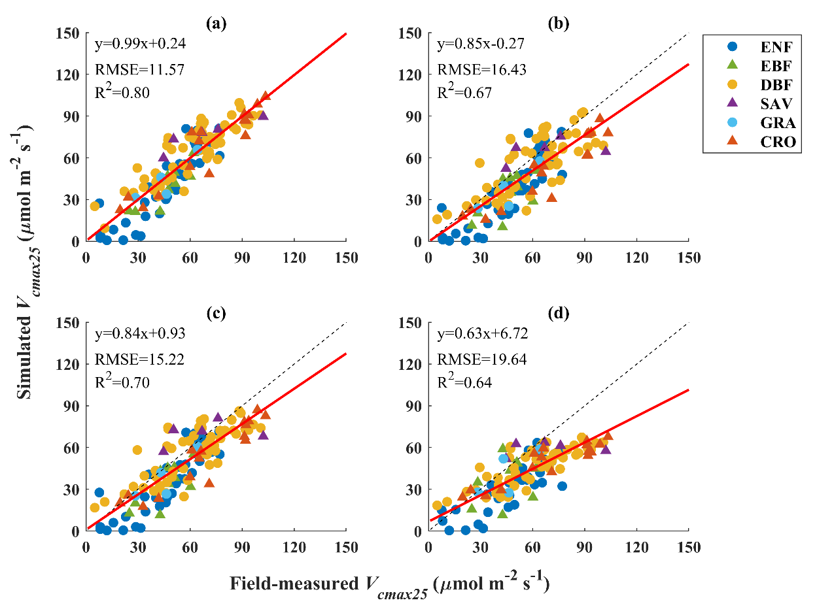

**Fig. S4.** Comparisons between all field measurements at 18 sites and **(a)** the top-leaf *Vcmax25* simulated using Eq. 14 with leaf absorptance (Scheme 1), **(b)** the canopy-average leaf-level *Vcmax25* simulated using Eq. 14 with canopy absorptance, **(c)** the top-leaf *Vcmax25* converted from **(b)** based on the empirical nitrogen vertical distribution coefficient, and **(d)** the top-leaf *Vcmax25* simulated using the model version in Jiang et al. (2020) with canopy absorptance and the empirical nitrogen vertical distribution coefficient. Canopy absorptance and the empirical nitrogen vertical distribution coefficient were estimated using the method in Jiang et al. (2020). Field-measured *rJV25* was adopted in **(a)** - **(c)**. The red lines are the regression lines, and the black dash lines are the 1:1 lines.

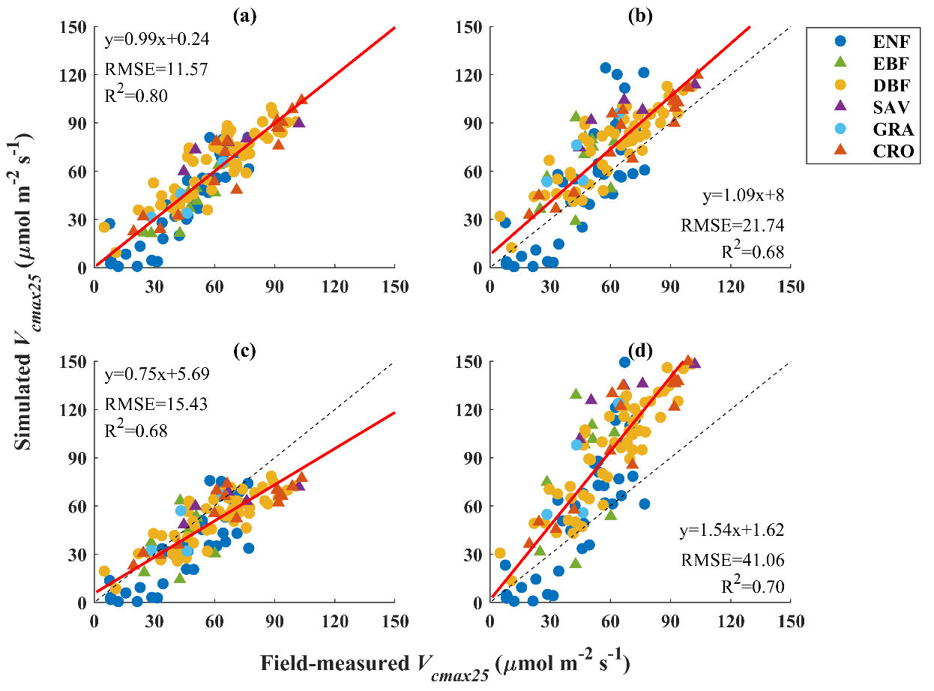

**Fig. S5.** Comparisons between all field measurements at 18 sites and **(a)** *Vcmax25* simulated using Eq. 14 (Scheme 1), **(b)** *Vcmax25* simulated using the model version in Smith et al. (2019), **(c)** *Vcmax25* simulated using the model version in Jiang et al. (2020), and **(d)** *Vcmax25* simulated using the model version in Peng et al. (2021). All inputs for the four simulations were the same, except that Scheme 1 adopted field-measured *rJV25*. The red lines are the regression lines, and the black dash lines are the 1:1 lines.

## References

Arellano, P., Tansey, K., Balzter, H., & Boyd, D. S. (2017a). Field spectroscopy and radiative transfer modelling to assess impacts of petroleum pollution on biophysical and biochemical parameters of the Amazon rainforest. *Environmental Earth Sciences*, *76*, 1-14.

Arellano, P., Tansey, K., Balzter, H., & Tellkamp, M. (2017b). Plant family-specific impacts of petroleum pollution on biodiversity and leaf chlorophyll content in the Amazon rainforest of Ecuador. *PloS one*, *12*(1), e0169867.

Darvishzadeh, R., Skidmore, A., Schlerf, M., & Atzberger, C. (2008). Inversion of a radiative transfer model for estimating vegetation LAI and chlorophyll in a heterogeneous grassland. *Remote sensing of environment*, *112*(5), 2592-2604.

De Santis, A., Chuvieco, E., & Vaughan, P. J. (2009). Short-term assessment of burn severity using the inversion of PROSPECT and GeoSail models. *Remote Sensing of Environment*, *113*(1), 126-136.

Enrique, G., Olmo, Manuel, Poorter, Hendrik, Ubera, Jose Luis, Villar, Rafael, 2016. Leaf mass per area (LMA) and its relationship with leaf structure and anatomy in 34 Mediterranean woody species along a water availability gradient. *PLoS One*, *11*(2), e0148788.

Feret, J. B., François, C., Gitelson, A., Asner, G. P., Barry, K. M., Panigada, C., ... & Jacquemoud, S. (2011). Optimizing spectral indices and chemometric analysis of leaf chemical properties using radiative transfer modeling. *Remote sensing of environment*, *115*(10), 2742-2750.

Jacquemoud, S., Bacour, C., Poilve, H., & Frangi, J. P. (2000). Comparison of four radiative transfer models to simulate plant canopies reflectance: Direct and inverse mode. *Remote Sensing of Environment*, *74*(3), 471-481.

Jiang, C., Ryu, Y., Wang, H., & Keenan, T. F. (2020). An optimality‐based model explains seasonal variation in C3 plant photosynthetic capacity. *Global Change Biology*, *26*(11), 6493-6510.

Kötz, B., Schaepman, M., Morsdorf, F., Bowyer, P., Itten, K., & Allgöwer, B. (2004). Radiative transfer modeling within a heterogeneous canopy for estimation of forest fire fuel properties. *Remote Sensing of Environment*, *92*(3), 332-344.

Peng, Y., Bloomfield, K. J., Cernusak, L. A., Domingues, T. F., & Colin Prentice, I. (2021). Global climate and nutrient controls of photosynthetic capacity. *Communications Biology*, *4*(1), 462.

Smith, N. G., Keenan, T. F., Colin Prentice, I., Wang, H., Wright, I. J., Niinemets, Ü., ... & Zhou, S. X. (2019). Global photosynthetic capacity is optimized to the environment. *Ecology letters*, *22*(3), 506-517.

Sow, M., Mbow, C., Hély, C., Fensholt, R., & Sambou, B. (2013). Estimation of herbaceous fuel moisture content using vegetation indices and land surface temperature from MODIS data. *Remote Sensing*, *5*(6), 2617-2638.